Laboratory work No. 11

Creation of video of files with use of the programs HyperCam, Adobe Premiere Pro, Windows Movie Marker, etc

Work purpose: Studying of work of video-tape editing of Adobe Premiere Pro. Obtaining practical skills on creation of clips, use and control of credits, video transitions and background music.
Introduction

Today the digital video entered practically each house. Camcorders, video tape recorders, the DVD-Video players stopped being luxury goods long ago and became customary household appliances without which it is difficult to provide the modern life.
The camcorders which appeared rather recently already managed to undergo essential changes. From bulky and expensive they turned into devices compact and available to any person. Now everyone had an opportunity to become both the screenwriter, and the director, and the operator.
Available video filming made our life more various. We began to remove everything: outdoor recreation, first steps of the child, graduation party, wedding. We don't leave a camcorder on a holiday, on walk and even on operation. All this led to the fact that in a house video library mountains of the finished shooting holders which it is simply impossible to understand often accumulated.
The home computer will help to collect all your video records in one movie which you with pride will be able to show to friends, acquaintances or colleagues.
Software developers for computers couldn't ignore amateur and professional video filming. Today there is already a set of different methods of processing of a digital video. Among software makers leaders who enhance the applications from year to year were accurately designated, giving to users all new and new chance for creation of a home video.
The Premiere Pro program provides all tools for creation of the movie - from transfer of the finished shooting material from the video camera on a hard drive of the computer before creation of a video file of any format which afterwards can be written on any carrier, to send by e-mail or to place on the page on the Internet. In the version of CS3 of the Premiere Pro program also the possibility of export of the project to one of the most powerful programs of an autoring the DVD - Adobe Encone appeared. One more innovation of this version of the Premiere Pro program is the possibility of creation of video for mobile devices, such as pocket computers or mobile phones, and by means of the utility of Device Central which is a Premiere Pro part, you will be able to see how the created video will look on the screen of phone or the pocket computer of this or that model.

1. First start of the Premiere Pro program
Premiere Pro program installation on the computer is made by means of the step by step master. It is necessary just to follow instructions on the screen.
We will launch the Premiere Pro program and we will create the new project further to get acquainted with the program interface.
1. Press the Start-up button and in the appeared main menu execute a command All programs → Adobe Premiere Pro CS3. On the screen the picture of the Premiere Pro program will appear, and then - a dialog with the invitation by the beginning of operations (fig. 1).
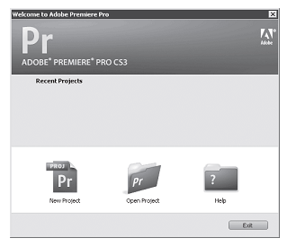
Figure 1 - Dialogue with the invitation by the beginning of work

The dialogue inviting by the beginning of work allows to create the new project, to open earlier created or to start help system. The Recent Projects list (The last projects) contains a list of earlier created projects, but as you start this program for the first time, this list will be empty.
2. Press the New Project button (The new project). On the screen the New Project window (The new project) (fig. 2) will appear. It is intended for installation of parameters of the created project.
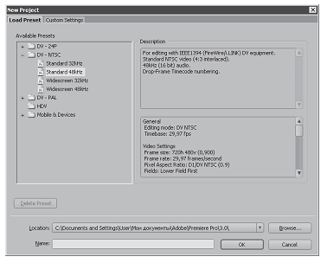
Figure 2 - New Project dialogue (New project)
We will choose ready preset of parameters of the project.
3. Make sure that New Project dialogue (The new project) is open on the Load Preset tab (To load procurement).
4. In the treelike Available Presets list (Available procurements) choose Standard 48kHz procurement located in the DV-PAL folder.
You chose procurement of Standard 48kHz from the DV-PAL folder as the PAL standard is supported by the majority of video cameras and TVs. The NTSC standard is distributed mainly in the countries of the western hemisphere and in Japan.
5. In the field of Location (Layout) specify the folder in which it is necessary to place the file of the project. For this purpose press the Browse button (Review) and select the necessary folder from the appeared Review of Folders dialog.
If earlier you didn't create the folder of the project, you can make it directly in the Review of Folders dialog, having pressed the Create the Folder button.
6. In the field of Name (Name) enter a name of the file of the project. The Premiere Pro program will create extension of the file automatically.
7. Press the button Apprx. the Dialog it will be closed, and on the screen we will appear a primary window of the Premiere Pro program (fig. 3).
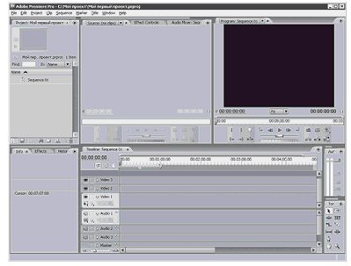
Figure 3 - Window of the Premiere Pro program

2. Interface of the Premiere Pro program

We will get acquainted with the interface of the Premiere Pro program. Knowledge of elements of the interface and their assignment will help you in case of execution of practical jobs.
The Premiere Pro interface is very convenient, functional and compact. The own part is assigned to each window and each tab here.

Timeline (Installation window)
The Timeline window (Mounting window) is, perhaps, most important window of the Adobe Premiere Pro program. In this dialog you will place and mount the initial components of the movie (video clips, sound files and a graphics). The Timeline window (A mounting window) consists of several video and soundtracks. On video tracks you will place clips and a graphics, that is image elements of your movie, and on sound - sound files (soundtrack elements) (a figure 4).
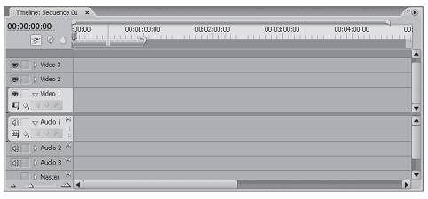
Figure 4 - Timeline Window (Installation window)
In the upper part of the Timeline window (A mounting window) the time line by which it is possible to determine a temporal line item of any frame of the created movie is located.
The thin vertical line passing perpendicular to Timeline window tracks (A mounting window) is called the cursor of current position of editing. By means of this line it is possible to position precisely on time clips, sound fragments and a graphics of the created movie.
In the Timeline window (A mounting window) the sequence of clips and a graphics in that order in which they shall follow in the movie is created. Imagine reproduction of fragments of the movie one after another. Quite so the majority of programs of non-linear editing of video works. You place fragments of the movie in the project and you place them in the necessary order. It is also the sequence.
Source screens (Source) and Program (Program)
In the top part of a main window of the Premiere Pro program two windows called by screens - Source (Source) and Program (Program) are located. Despite similarity of these windows, appointment at them a miscellaneous.
The Program screen (Program) is intended for control of the image of the created movie (figure 5). In this window it is possible to look at fragments of the created movie or all movie entirely, and also to see results of editing and use of various effects and transitions.
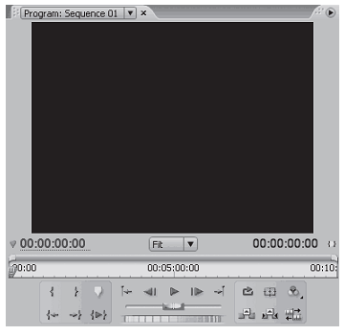
Figure 5 Program Screen (Program)
On the Source screen (Source) you can view clips before location in the sequence, and also having edited them, having cut off excess fragments (fig. 6). At present in the Source screen (Source) clips aren't loaded therefore elements of the interface of this window are inactive.
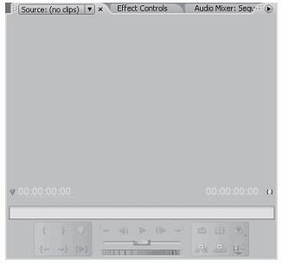
Figure 6 - Source Screen (Source)
At some stages of creation of the movie the Source screen (Source) isn't necessary therefore for the purpose of economy of space of the monitor producers of the program added on it additional elements of management, having arranged them on separate tabs:
- Effect Controls (Management of effect). On this tab elements of management for change of properties of video and sound effects and transitions are located. At present your project doesn't contain any initial components therefore this tab is empty. In process of addition of effects and transitions to the project on the Effect Controls tab (Management of effect) will be appear new elements of management;
- Audio Mixer (Sound mixer). On this tab elements of management for change of characteristics of a soundtrack of the created movie are located. Here you can change the loudness and balance of each soundtrack or general soundtrack (fig. 7).
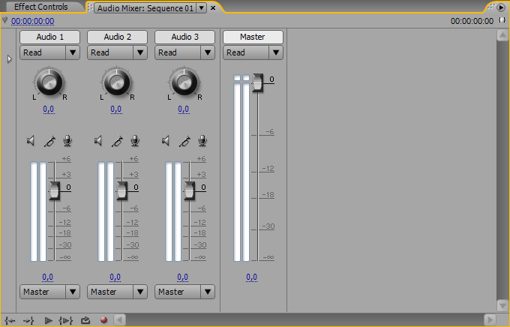
The figure 7 - Audio Mixer (A sound mixer)

Info tabs (Information), History (History), Effects (Effects)

In the left lower part of a window of the Premiere Pro program the window with three tabs (fig. 8) is located:
- Info (Information) displays information on the selected clip, the sound or graphic file of the project: duration, permission, a temporary position of the beginning and the termination in the sequence etc. This tab has exclusively informative character;
- History (History) contains the replenished list of all your actions in the course of one session over the project. Each action (addition of the clip, undercutting, use of effect, change of properties of effect etc.) adds new point to the list of the History tab (History). By means of the list of this tab it is possible to return back easily, having cancelled one or several last actions;
- The list of various video and sound effects and transitions supports Effects (Effects). All effects and transitions according to the destination and to the nature of action are united in the folders called by baskets. It is possible to open this or that folder (basket), having pressed the triangular button located to the left of an icon of the folder. In the same place you can create own baskets in which it is possible to place often used effects and transitions.
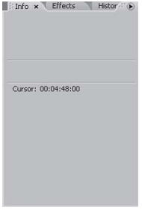
Figure 8 - A window with the Info tabs, History, Effects

Other windows
In the left upper part of a window of the Premiere Pro program the Project window (Project) is located. In this dialog all initial components of the movie (clips, sound and graphic files) are placed. Here automatically there are components which you create in the course of operation over the movie (files of titles and fragments of clips).
In the upper part of the Project window (Project) (fig. 9) the small window of print preview in which it is possible to watch the clip or the graphic file before location on the Source screen (Source) or the sequence of Timeline (A mounting window) is located. In this dialog it is also possible to create baskets for sorting of different initial components of the movie. For example, one basket may contain video fragments, another
sound files etc. It can be convenient if the movie is created from a large number of fragments.
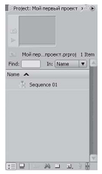
Figure 9 - Project Window (Project)

In the right lower part of a window of the program the palette of tools is located. Pressing that or other button on this palette, it is possible to choose various instruments of editing. On a palette of tools you learn about purpose of concrete buttons in the course of performance of practical tasks (fig. 10).
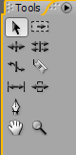
Figure 10 - Palette of tools

Slightly above a palette of tools there is a small window with the movie soundtrack loudness level indicator. By means of this indicator it is possible to estimate the level of volume of sound and to change him.

3. Work performance order

Task: Using graphic and sound files, it is required to create the video, lasting from 3 up to 5 minutes. Between the termination of each video record and the beginning of the following video record it is necessary to create video transitions. The soundtrack of the movie has to be at one level. The video has to come to an end with credits. Credits have to be "dynamic".

1. Creation of the project. To start the Adobe Premiere program, in the appeared New Project window to choose the folder in which files of the project, the name for him and properties of the project will be stored.
2. Loading of materials of the project. To import audio and video fragments, necessary for work, as the File — Import team to a window of the Project project. To place them on the Temporary film Timeline dragging by "mouse" from the Project window.
3. Creation video and audio of transitions. Having selected the Effects tab from the Project window it is possible to use transitions of Video transitions for video and Audio Transitions for audio. Also at will it is possible to use Audio and Video Effects from the same window.
4. Alignment of the volume level of audiomaterials.
5. Creation of titles. In the Title window – New title to enter a caption name, to write the text, to select transition.
6. Saving materials in the .avi format. For final mounting of a video topic choose the File — Export — Movie command. Select the name and a format for a final video topic from the appeared window.
4. Control questions
1. What video-tape editing types exist? In what their differences?
2. In what difference of the PAL and NTSC standards?
3. What formats of video files exist?
4. What is personnel frequency?
5. What is video transition?
6. Main functions of a sound mixer?

